Monitoring of Mediterranean coastal areas:
problems and measurement techniques

---- (2 spacing lines) ----
Antonio Bianchi¹, Maria Verdi²
¹CNR – Institute of BioEconomy, via Madonna del Piano – 50019 Sesto Fiorentino Florence (Italy),
phone +39 055 3033711, e-mail: antonio.bianchi@ibe.cnr.it
²SISEF, Viterbo (Italy)

---- (2 spacing lines) ----
Abstract – These guidelines include complete descriptions of the fonts, spacing, and related information for producing your manuscripts. Please note that the paper should be prepared according to this style guide.
Each communication should not exceed 10 pages, A4 format, including tables, illustrations, abstract, and references. The A4 size (210 x 297 mm) pages must be set as follow: margins left and right 40 mm, top 27 mm, bottom 75 mm. From edge: header 12,7 mm, footer 62,5 mm. Footnotes must be insert inside the margins.
Abstract and text must be written in Times New Roman font, size 10, line spacing exactly 12 points. All paragraphs should be first line indented 13 mm. Text must be fully justified.
Title of the paper should be centred at the top of the first page, Times New Roman font 12 points, capital and bold, 12 points spacing line. Two spacing lines should be between title and author’s names (24 points). Full authors’ name should be written centred Times New Roman, 10 points. Present the authors’ affiliation below the names. For the corresponding author should be presented affiliation name, address, telephone, fax, and e-mail. Times New Roman point 9 should be used. Indicate all the affiliations with a superscript number immediately after the author’s name and in front of the appropriate address. The abstract should be of maximum length of 1 page.

---- (2 spacing lines) ----
Headings
---- (1 spacing line) ----
The paper should be organized as follow: Introduction, Materials and Methods, Results, Discussion, Conclusion, Acknowledgements, References. Headings must be left indented 13 mm, Times New Roman 12 pt., bold, first letter capitol.

---- (2 spacing lines) ----
Figures, tables, formulas
---- (1 spacing line) ----
Figures and tables should be embedded in the paper, without text besides. Figures should be clear, well readable, and preferable in jpg, TIF, GIF o BMP format. Double spacing line should be left between text and figure (or table). Captions should be of the same width of figures and tables and should be put below the figures or above the table. The captions should be progressively numbered as the correspondent figure (table). The number should be indicating as follow: Figure 1 – Description…. Two spacing should be left between the caption and the text. Examples:

---- (2 spacing lines) ----
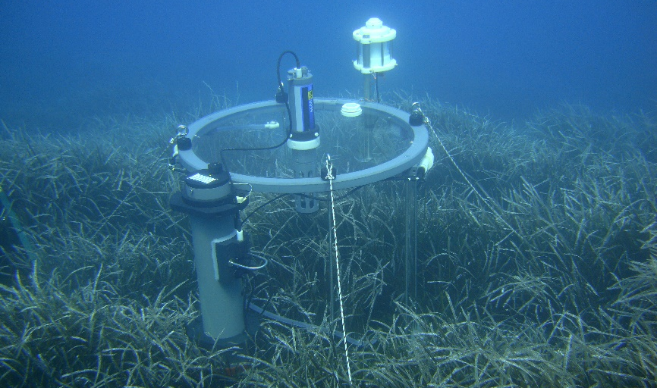
Figure 5 – A test to verify the Chamber functionality was conducted in the Cala Villamarina (Archipelago of Maddalena, North Sardinia) on a Posidonia Oceanica meadow at a depth of 9 m in July 2009.

---- (2 spacing lines) ----
Table 2 – Recovery rate and percentage of displaced tracers after the first (6 h) and second (24 h) surveys at Barbarossa beach as a function of the injection position of the pebbles.
 | Recovery rate |  | Displaced tracers
Injection position | 6 h | 24 h | 6 h | 24 h
Fair-weather berm | 100 % | 85 % | 8 % | 19 %
Swash zone | 81 % | 73 % | 65 % | 69 %
Step | 96 % | 96 % | 0 % | 35 %
Total | 92 % | 85 % | 24 % | 41 %

---- (2 spacing lines) ----
Mathematical equations should be written with the same characters as in the text, not italics, pt 12. They should be left indented and progressively numbered. Formulas’ number should be right indented. Leave double spacing between text and formulae. Example:

---- (2 spacing lines) ----
1

---- (2 spacing lines) ----
Units
---- (1 spacing line) ----
Use The International System of Units (SI). Use exponential formulas instead of fractional formulas, e.g.: Wm⁻²; Js⁻¹m⁻². For further information, regarding SI, please refer to http://www.bipm.org/en/si/si_brochure/.
The mineral content must be written in following way: N, P, K, etc. for the elements; ¹⁴C, ³²P, etc. for the isotopes; H⁺, Mg²⁺, etc. for the ions.
For other information please contact Scientific Secretariat (e-mail simposio@ibe.cnr.it phone +39055 5226060 - 6030).

---- (2 spacing lines) ----
Paper submission
---- (1 spacing line) ----
Full version of paper (MS®-Word and pdf format) must arrive, by email to simposio@ibe.cnr.it, not later than June 14th, 2022. An accompaniment letter, including all the details of the corresponding author (address, phone number, e-mail), should be added.

---- (2 spacing lines) ----
References
---- (1 spacing line) ----
The list of references should be numbered and arranged alphabetically on author’s name. References should be cited in the text only by the number reported in square parenthesis. Publications of the same author should be arranged chronologically. When the author is unknown must be indicated as Anonymous.
Use the following system for arranging your references:
(For periodicals)
- Dwyer M. J. (1969) - The effect of drought control response on the performance of agricultural tractors, J. Agri. Eng. Res. 14 (4), 295 - 312.
(For books)
- Nerli N. (1961) - Meccanica Agraria, 7ª ed., Patron, Bologna.
(For proceedings)
- Kinsey J.C., Eustice R.M., Whitcomb L.L. (2006) - A survey of underwater vehicle navigation: Recent advances and new challenges, Proceedings of the IFAC Conference of Manoeuvring and Control of Marine Craft, Lisbon, Portugal, 20–22 September 2006, Volume 88, pp. 1–12

The footnotes refer in the text with a superscript number. The numeration is progressive. The footnotes must be insert in the same page in which they are referred by the text. The font is Times New Roman, size 9.

