STUDY OF SIGNIFICATIVE MEDITERRANEAN COASTAL AREAS
Antonio Bianchi, Laura Neri, Giuseppe Rossi, Maria Verdi
Abstract: These guidelines include complete descriptions of the fonts, spacing, and related information for producing your manuscripts. Please note that the paper should be prepared according to this style guide.
Each communication should not exceed 12 pages, including tables, illustrations, abstract, and references and it must be written exclusively in English.
The page size is 159,8 x 234,9 mm; all the margins of pages must be set as 22 mm. From edge: header 16 mm, footer 18 mm.
Title of the paper should be alignment at left on the top of the first page, Garamond font 12 points, capital and bold, spacing line at least 12 mm. There must be a space of 6 points between the title and the author's name.
Full authors’ name should be written at left Times New Roman, 10 points.
Please insert the authors' affiliation at the bottom of the first page (following the format of the red explanatory area).
Abstract must be written in Garamond font, size 9, line spacing at least 10 points.
Text must be fully justified.
Indentation of abstract is 5 mm at left and the same at right.
The abstract total length should be between 600- and 1200-characters including spaces.
In first page of paper must be only title, abstract, keywords, and affiliations.
Keywords: no more than 5 keywords

Advice: This authors guide is set up with the typographical rules for the paper and therefore it can be used as a template.
Paper submission
Full version of paper (MS®-Word and pdf format) must arrive, by email to simposio@ibe.cnr.it, not later than June 11th, 2024.

Headings
The paper should be organized as follow: Introduction, Materials and Methods, Results, Discussion, Conclusion, Acknowledgements, References.
Headings must be left alignment, Garamond 11 pt., bold, first letter capitol. The line spacing of each Heading paragraph must be set at least 12 points; the amount of space before the Heading is 18 points and 6 points after the heading.
All paragraphs should be first line indented 5 mm. Text must be fully justified. The text must be written in Times New Roman font, size 10, the line spacing must be set at least 11 points.
All non-English terms must be written in the appropriate font but in italics.
Footnotes must be insert inside the margins.
Figures, tables, formulas
Figures and tables should be embedded in the paper, without text besides. Figures should be clear, well readable, and preferable in jpg, TIF, GIF o BMP format. Double spacing line should be left between text and figure (or table). Captions should be of the same width of figures and tables and should be put below the figures or above the table. The captions must be written in Times New Roman font, size 9, the line spacing must be set at least 11 points.
The captions should be progressively numbered as the correspondent figure (table). The number should be indicating as follow: Figure 1 – Description…. Two spacing should be left between the caption and the text. Examples:

---- (2 spacing lines) ----
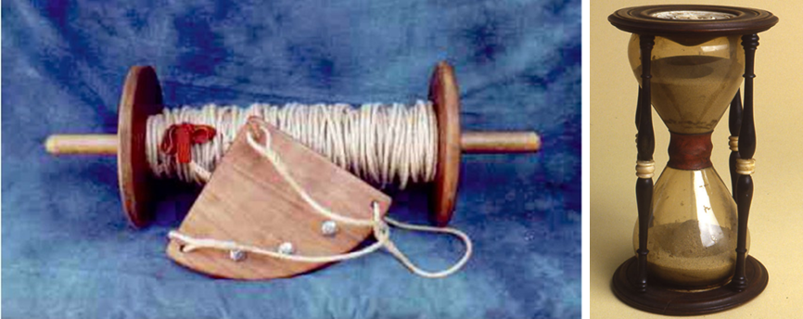
Figure 6 – Ship log and sandglass to estimate the relative speed of the ship.

---- (2 spacing lines) ----
At the same way for the tables:
Table 1 – Recovery rate and percentage of displaced tracers after the first (6 h) and second (24 h) surveys at Barbarossa beach as a function of the injection position of the pebbles.
 | Recovery rate |  | Displaced tracers
Injection position | 6 h | 24 h | 6 h | 24 h
Fair-weather berm | 100 % | 85 % | 8 % | 19 %
Swash zone | 81 % | 73 % | 65 % | 69 %
Step | 96 % | 96 % | 0 % | 35 %
Total | 92 % | 85 % | 24 % | 41 %

---- (2 spacing lines) ----
Mathematical equations should be written with the same characters as in the text, not italics, pt 10. They should be left indented and progressively numbered. Formulas’ number should be right indented. Leave double spacing between text and formulae. Example:

---- (2 spacing lines) ----
${\text{ET0}}_{\text{FP}}\text{=}\frac{\text{1}}{\text{λ}}\frac{\text{∆}}{\text{∆+}\text{γ}}\text{+}\left({\text{R}}_{\text{n}}-\text{G}\right)\text{+}\frac{\text{γ}}{\text{∆+}\text{γ}}\left({\text{e}}_{\text{s}}-{\text{e}}_{\text{a}}\right) 0,27\left(1+\frac{\text{u}}{\text{100}}\right)$ 1
Units
Use The International System of Units (SI). Use exponential formulas instead of fractional formulas, e.g.: Wm⁻²; Js⁻¹m⁻². For further information, regarding SI, please refer to http://www.bipm.org/en/si/si_brochure/.
The mineral content must be written in following way: N, P, K, etc. for the elements; ¹⁴C, ³²P, etc. for the isotopes; H⁺, Mg²⁺, etc. for the ions.
For other information please contact Scientific Secretariat (e-mail simposio@ibe.cnr.it phone +39055 5226060 - 6030).
References
The list of references should be numbered and arranged alphabetically on author’s name. References should be cited in the text only by the number reported in square parenthesis. Publications of the same author should be arranged chronologically. When the author is unknown must be indicated as Anonymous.
Use the following system for arranging your references:
(For academic journals)
- Dwyer M. J. (1969) - The effect of drought control response on the performance of agricultural tractors, J. Agri. Eng. Res. 14 (4), 295 - 312.
(For books)
- Nerli N. (1961) - Meccanica Agraria, 7ª ed., Patron, Bologna.
(For proceedings)
- Kinsey J.C., Eustice R.M., Whitcomb L.L. (2006) - A survey of underwater vehicle navigation: Recent advances and new challenges, Proceedings of the IFAC Conference of Manoeuvring and Control of Marine Craft, Lisbon, Portugal, 20–22 September 2006, Volume 88, pp. 1–12

The footnotes refer in the text with a superscript number. The numeration is progressive. The footnotes must be insert in the same page in which they are referred by the text. The font is Times New Roman, size 9.

